2023 Ontario Provincial Championship
Bay of Quinte Yacht Club July 22-23 2023
Belleville, ON

This Counter Regatta is sanctioned by the Canadian Shark Class Association

ATTACHMENT A
to the
CSCA STANDARD SAILING INSTRUCTIONS (SSI)

2 NOTICES TO COMPETITORS
Notices to competitors will be posted on the official notice board(s) located at the south window of the BQYC Clubhouse.

4 SIGNALS MADE ASHORE
Signals made ashore will be displayed at the club’s flagpole on the south side of the clubhouse.

RACING AREAS
Attachment C shows the location of racing areas.
  - Course Area 1 - Belleville Bay East of the bridge to Pr. Edward County
  - Course Area 2 - Belleville Bay West of the bridge to Pr. Edward County
  - Course Area 3 - Big Bay – (approx. 5 nm east of the club)
  - The race area for the day will be announced at the skippers meeting and posted on the Notice to Competitors window.

THE COURSES
  - Course diagrams are in Attachment B. These replace the courses from RRS Appendix S.

MARKS
  - Marks 1, 2p and 2s will be Orange Tetrahedrons.
  - The offset mark 1a will be a Red Ball.
  - New marks as provided in instruction 12.1 will be Yellow.
  - The starting marks will be the race committee signal boat at the starboard end and a Light Orange Cylinder at the port end.
  - The finishing marks will be the race committee signal boat at the starboard end and an Orange Cylinder at the port end.

THE START
  - The starting line will be between a staff displaying an orange flag on the starboard end signal boat and the course side of the port-end starting mark.
  - A boat that does not start within 5 minutes after her starting signal will be scored Did Not Start without a hearing. This changes RRS A5.1 and A5.2 and SSI 11.2.

CHANGE OF THE NEXT LEG OF THE COURSE
12.4 Courses will not be shortened to fewer than 2 legs, not including the leg between marks 1 and 1a. This changes SSI 12.4.

THE FINISH
  - The finishing line will be between a staff displaying a blue flag on the starboard end signal boat and the course side of the port-end finishing mark.
  - The Race Committee may award finishing positions to boats on course. Method and order to be determined by the race committee. This changes RRS A5.2 and SSI 13.2.

PROTESTS AND REQUESTS FOR REDRESS
  - The race office is located beside the kitchen in the BQYC clubhouse.
15.3 The protest room is located at the North-West end of the BQYC clubhouse.

Attachment B
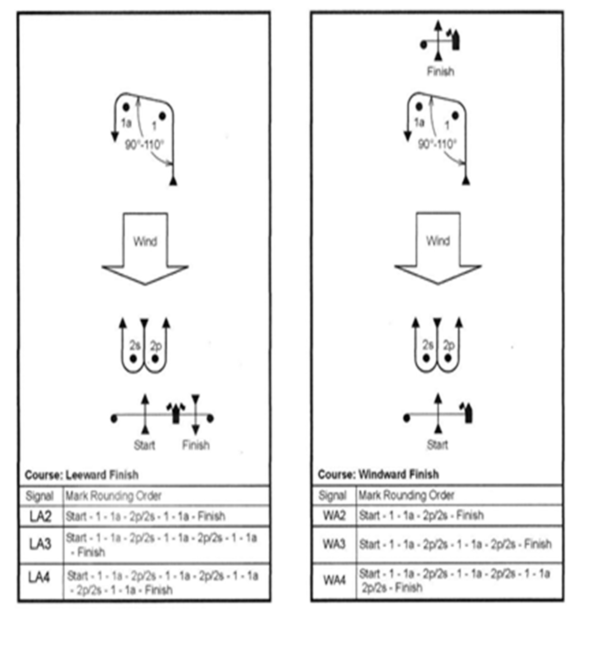

Attachment C
Area 1
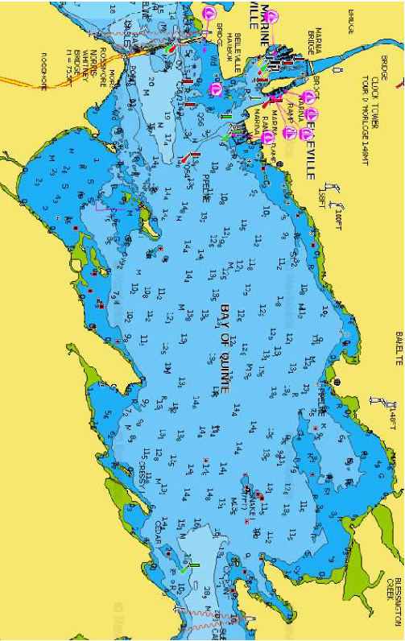

Area 2
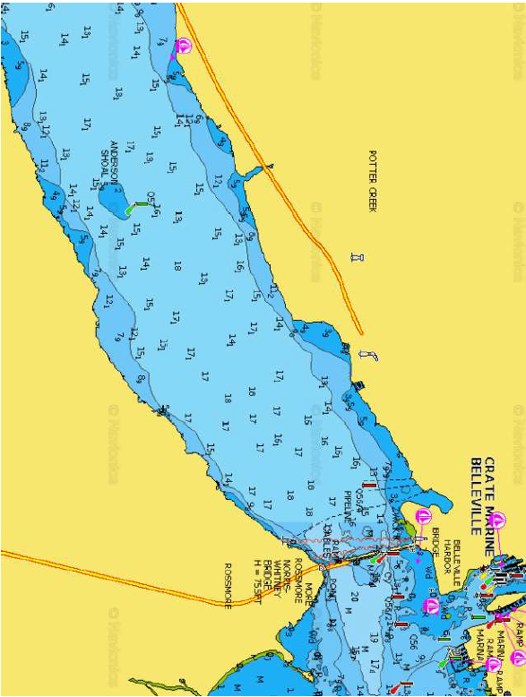
Area 3

